Name:
Tutor:
Course:
Date:
Types of printing
There are four main types of printing. These include relief printing, engraving, lithography, and stencil. Relief kind of printing involves printing from the protruding surfaces of woods, inking the required part and cutting off the unwanted parts using tools. Printing images of this type are cheap as it involves applying the preferred ink on the surface of the matrix and pressing it firmly on the paper. This kind of printing is cost saving because it eliminates the purpose of the printing press since the article is pressed by hand. Unlike the intaglio process, the recessed areas are the ones used for printing.
Another type of printing is known as engraving. Engraving is usually done on metals like copper, steel, gold or silver. Desired designs are made on the hard, smooth surfaces of the metals by cutting grooves in them. Unlike relief printing, engraving involves pushing ink in the lines of the design, wiping clean the surface a leaving only the lines with wet ink sheet of paper is then fixed on the plate which is run across the printing process. It should be known that wood engraving does not lie in this category of printing but the relief printing. The third type of printing is planography that involves printing from a flat surface. It is also known as lithography. This type operates because water and oil do not mix. Litho means stone in Greek, so the printing is usually done from a stone (Xi 15). The final type of printing is a stencil. A stencil is a material with cut designs or that which designs are punched from. Ink is then poured through the openings to the surface for printing.
Traditional uses of the prints. Relief printing is the oldest type whose common form is woodcut. In the past, this printing was used free print test thus used as book illustrators (Ziyu 43). Engraving type was traditionally used to produce images by the artists.it was also used to make maps as well as magazine and book illustrators. This type was used to paint caves I the past.
An example of a traditional printmaker is Emily Whipple. He made a woodcut artwork named "self-inflicted" This is the kind which the surface of the material is cut or designed into any form. In this case, Emily created an image, applied ink and passed the plate through a hand run printing press. This artist is a tradition as portrayed by the type of printing used. Below is an image of her woodcut.
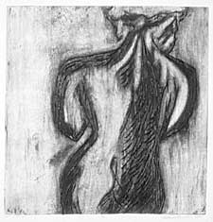
James Alphege Brewer used prints in new modern ways and brought out the very best. He used woodcut in new ways by making drawings on the surfaces then applying colours using hands.
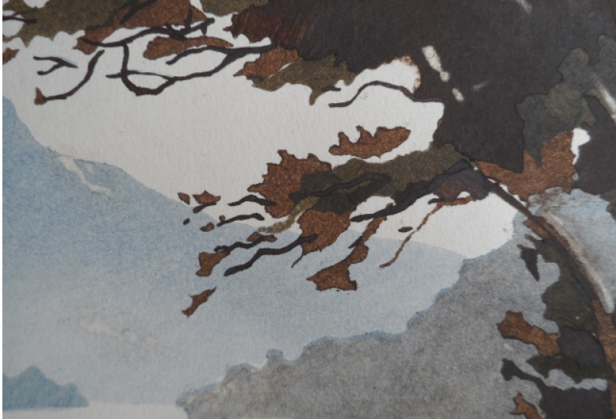

Work cited
He, Xi, et al. "Characterization of stencil printing parameters for fine pitch wafer bumping." Electronic Packaging Technology (ICEPT), 2014 15th International Conference on. IEEE, 2014.
Liu, Ziyu, et al. "Interfacial reaction between Sn3. 0Ag0. 5Cu solder and ENEPIG for fine pitch BGA by stencil printing." Journal of electronic materials 43.9 (2014): 3341.

